Exp no.3

**DML Commands – INSERT, SELECT, UPDATE, DELETE**

Output:

1.

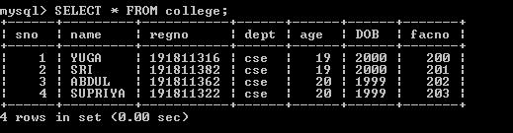

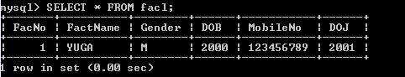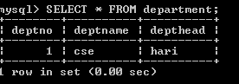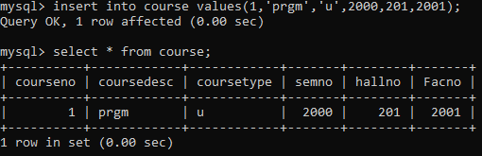

2.



3.



4.

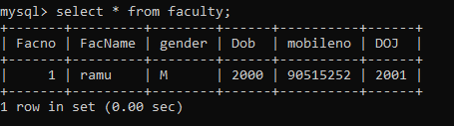

5.

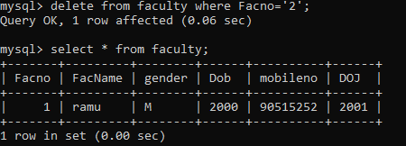

6.

